Sample Output 0

32 → number = 32

STDIN Function

Sample Input 0

Sample Case 0

The only line contains an integer, number.

Input from stdin will be processed as follows and passed to the function.

Input Format for Custom Testing

0 ≤ number < 2

31

Constraints

number.

int: an integer 0 or 1 matching the 4th least significant digit in the binary representation of

Returns:

int number: a decimal integer

fourthBit has the following parameter(s):

Complete the function fourthBit in the editor below.

Function Description

·

The value of the 4

index from the right in the binary representation is 0.

th

= (10111)

.

2

·

Convert the decimal number 23 to binary number: 23

= 2

+ 2

+ 2

+ 2

10

4

2

1

0

number = 23

Example:

determine the value of the the 4

least significant digit.

th

starting from the right starting with 1. Given a decimal number, convert it to binary and

A binary number is a combination of 1s and 0s. Its n

least significant digit is the n

digit

Q)

th

th

WEEK 12

·

The value of the 4th index from the right in the binary representation is 1.

10

= (1001101)

.

2

·

Convert the decimal number 77 to binary number: 77

Explanation 1

1

Sample Output 1

77 → number = 77

Sample Input 1

Sample Case 1

·

The value of the 4th index from the right in the binary representation is 0.

10

= (100000)

.

2

·

Convert the decimal number 32 to binary number: 32

Explanation 0

0

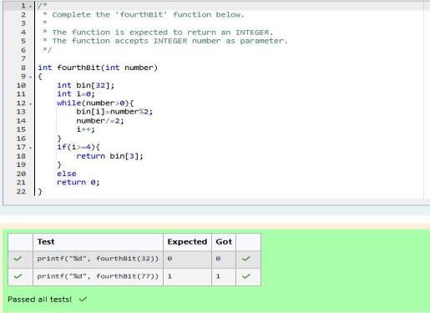

Sample Input 0

Sample Case 0

The second line contains an integer p, the 1-based index of the factor to return.

The first line contains an integer n, the number to factor.

Input from stdin will be processed as follows and passed to the function.

Input Format for Custom Testing

1 ≤ p ≤ 10

9

1 ≤ n ≤ 10

15

Constraints

then 0 is returned

int: the long integer value of the p

integer factor of n or, if there is no factor at that index,

th

Returns:

int p: the index of the factor to be returned

int n: the integer whose factors are to be found

pthFactor has the following parameter(s):

Complete the function pthFactor in the editor below.

Function Description

then 4 is returned. If p > 6, 0 would be returned.

The factors of 20 in ascending order are {1, 2, 4, 5, 10, 20}. Using 1-based indexing, if p = 3,

p = 3

n = 20

Example

p

element, return 0.

th

a number) and then return the p

element of the list, sorted ascending. If there is no

th

Determine the factors of a number (i.e., all positive integer values that evenly divide into

Q)

Factoring n = 1 results in {1}. The p = 1st factor of 1 is returned as the answer.

Explanation 2

1

Sample Output 2

1 → p = 1

1 → n = 1

Sample Input 2

Sample Case 2

returned as the answer.

Factoring n = 10 results in {1, 2, 5, 10}. There are only 4 factors and p = 5, therefore 0 is

Explanation 1

0

Sample Output 1

5

→ p = 5

10 → n = 10

-----

--------

STDIN

Function

Sample Input 1

Sample Case 1

Factoring n = 10 results in {1, 2, 5, 10}. Return the p = 3

factor, 5, as the answer.

rd

Explanation 0

5

Sample Output 0

3

→ p = 3

10 → n = 10

rupees or "0" otherwise.

For each test case, print a single line containing the string "1" if you can make exactly N

Output

·

The test case contains a single integer N.

Input

1<=N<=10^12

1<=T<=100

Constraints:

any number of time. Can you achieve the desired amount N using these hacks.

of money you own by 10, while the second can multiply it by 20. These hacks can be used

exactly N rupees in your account. You wrote two hacks, first hack can multiply the amount

You are a bank account hacker. Initially you have 1 rupee in your account, and you want

Q)

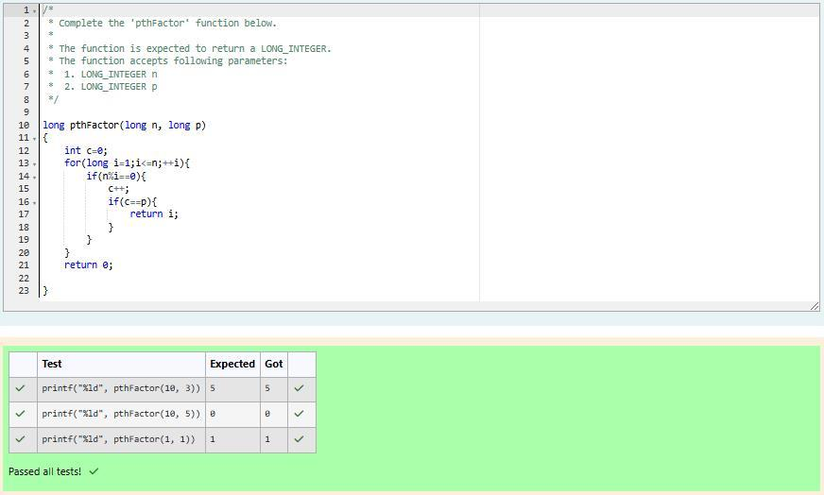

0

SAMPLE OUTPUT

2

SAMPLE INPUT

1

SAMPLE OUTPUT

1

SAMPLE INPUT

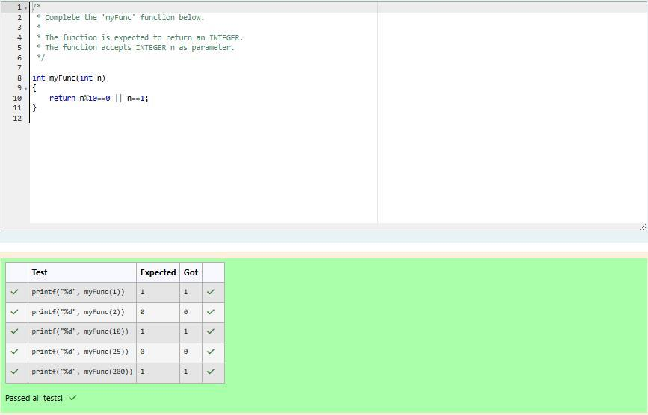

Sample Input 1

This is the only way in which 10 can be expressed as the sum of unique squares.

10 = 1

+ 3

2

2

sum of squares of unique numbers.

If X = 10 and N = 2, we need to find the number of ways that 10 can be represented as the

Explanation 0

1

Sample Output 0

2

10

Sample Input 0

Output a single integer, the number of possible combinations calculated.

Output Format

2 ≤ N ≤ 10

1 ≤ X ≤ 1000

Constraints

The second line contains an integer N.

The first line contains an integer X.

Input Format

N: the integer power to raise numbers to

X: the integer to sum to

powerSum has the following parameter(s):

represents the number of possible combinations.

Complete the powerSum function in the editor below. It should return an integer that

Function Description

adding up to 13. The only solution is 2

+ 3

.

2

2

For example, if X = 13 and N = 2, we have to find all combinations of unique squares

the N

powers of unique, natural numbers.

th

Find the number of ways that a given integer, X, can be expressed as the sum of

Q)

(1 + 8 + 27 + 64 = 100). There is no other way to express 100 as the sum of cubes.

100 can be expressed as the sum of the cubes of 1, 2, 3, 4.

Explanation 2

1

Sample Output 2

3

100

Sample Input 2

100 = (10

) = (6

+ 8

) = (1

+ 3

+ 4

+ 5

+ 7

)

2

2

2

2

2

2

2

2

Explanation 1

3

Sample Output 1

2

100

